Capital Public Radio's mission is to provide a trusted source of information, music and entertainment for curious and thoughtful people, in an efficient, sustainable way, strengthening the civic and cultural life of the communities we serve.

Capital Public Radio’s vision is to be a valued, vital, and vibrant service that is indispensable to listener’s lives, inspires people to look at the world in different ways, capitalizes on emerging opportunities, and speaks with civility and respect.

7055 Folsom Blvd, Sacramento, CA 95826 | T (916) 278-8900 | F (916) 278-8989 | www.capradio.org

NAME: LAST FIRST MIDDLE
EMAIL ADDRESS:
LOCAL ADDRESS: STREET CITY STATE ZIP |  |  |  |  |  |  |  |  |  | HOME PHONE
PERMANENT ADDRESS: STREET CITY STATE ZIP |  |  |  |  |  |  |  |  |  | WORK PHONE
Title of current opening for which you are applying (Note: Separate applications are required for each position.) |  |  |  |  |  |  |  |  |  | MESSAGE PHONE
Are you 18 years of age or older? | Yes |  | No |  |  |  | Date Available to begin employment:
If you have attended school or been employed under another name please give name. |  |  |  |  |  |  |  |  | Minimum salary requirement:
 |  |  |  |  |  |  |  |  | $ | Per hour/month

If hired can you present evidence of your legal right to work in the United States? |  |  |  |  |  |  |  |  | Yes |  | No
Have you ever been convicted of a felony? |  |  | Yes |  | No |  |  |  | A conviction will not necessarily disqualify an applicant from employment.
Applying for: | Full-time |  | Part-time |  | Temporary (4 months or less)
Are you willing to work evenings and weekends? |  |  |  | Yes |  | No |  |  | Occasionally
Would you consider working an irregular schedule or being on call? |  |  |  |  |  |  | Yes |  |  | No

Briefly describe how your interests, aptitudes, education, and experience (voluntary and paid) relate to the minimum qualifications, special skills, and duties of the specific position for which you are applying. (You may use additional sheets if necessary.)
Why do you want to work for Capital Public Radio, Inc.?
What led you to apply (name of newspaper, employment agency, organization, or name of person referring you, etc.)?
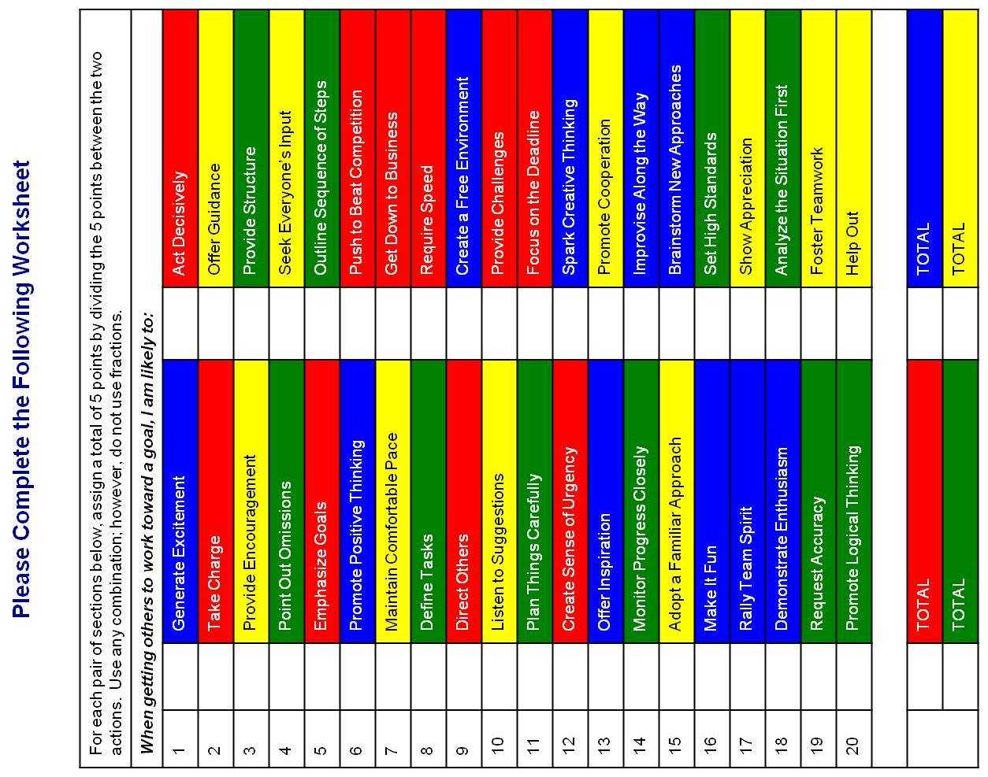

Please answer all the behavioral questions below:
I enjoy working in an environment that is
The ideal organizational culture for me can be described as (Please limit response to 10 words)
is/are unacceptable in a hospitable and collegial workplace.
If you want the best from people, you should
From the list below, please highlight/select three competencies important to you to do your job:

Judgment Technical Knowledge Motivational Fit Ability to Learn Bias for Action Planning/Organizing Teamwork Building Trust

Political Acumen Visionary Leadership Analysis Communication Persuasion Influence Tenacity Resilience Energy Delegation

Adaptability Tolerance for Stress Strategic Leadership

I certify that all of the above statements are true and complete to the best of my knowledge. I understand that any falsification or intentional omission of material facts may result in my failure to receive an offer or, if I am hired, my dismissal from employment. If hired, I agree to conform to the policies of Capital Public Radio, Inc. I agree that if hired, my employment with Capital Public Radio, Inc. is at-will and can be terminated with or without cause and with or without notice either by me or Capital Public Radio, Inc. I authorize Capital Public Radio, Inc. to obtain references, past employment, background, criminal records, and credit checks. I understand that all offers of employment are conditioned on my submission of satisfactory proof of my identity, legal authority to work in the United States and that I am 18 years of age or older. I understand that this application is active for 60 days and if I want to be considered for employment beyond 60 days I must reapply.
Signature |  | Date:

Capital Public Radio is an Equal Opportunity Employer. 